**FAST National University, Karachi**



**Project Report**

**Computer Organization & Assembly Language**

**Word Guesser**

**Instructor:**

***Sir Nadeem Ghouri***

**Group Members:**

***Muhammad Talha 21K-3349***

***Muhammad Hamza 21K-4579***

***Muhammad Taha 21K-3316***

**TOOLS AND TECHNIQUES**

* The software we have used is visual studio 2019.
* 8086(MASM) is the base language used for the logic building of our game.
* We have used registers and other attributes such as stack frames and data segments.
* Most of the code has loops and functions with arguments passed within it.

**ABSTRACT**

The Game that we have built is based upon multiple algorithms, once a user thinks of a word in his mind our game will ask him the number of alphabets then it will ask the user in which group your alphabets belong to this process will be done twice and at the end, if the game is played right according to the instructions given user will get his desired word. The range of alphabets is (3-8) you cannot guess a word if it's less than 3 alphabets or more than 8 alphabets.

**PROBLEM STATEMENT**

The main problem of this project was to make an efficient algorithm which should work for any user who uses the English Language so after trying multiple logics and encountering numerous errors we were successful in generating a logic which works perfectly on every assumption.

**CONTRIBUTIONS**

**- *Muhammad Talha 21K-3349***

* Working on Procedures and functionalities.
* Working on arrays according to the letters.

- ***Muhammad Hamza 21K-4579***

* Initialization of all required variables and arrays.
* All the Work in the Main procedure including the loops and functions.

**- *Muhammad Taha 21K-3316***

* Conditional Working
* Logic Building

**DRY RUN AND LOGIC**

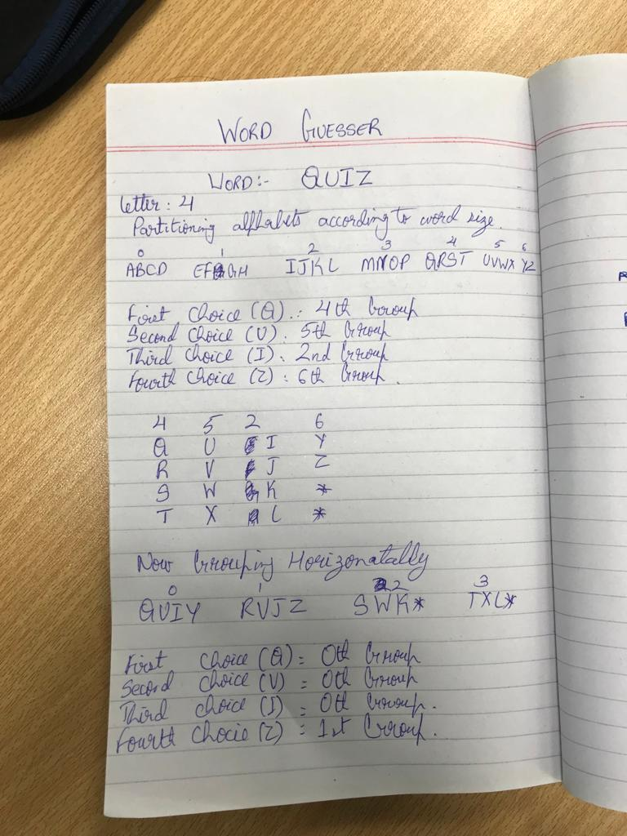

**METHODOLOGY**

* We have stored the English alphabet as an array and the user inputs the length of the word which should be a minimum of 3 letters and a maximum of 8 letters.
* Then the array of our alphabet is partitioned according to the user's word size preference.
* After this, groups are made starting with 0, according to the length of the word. Let’s say that the word is of 3 letters then the alphabet is divided into groups of 3 letter each
* Then the user selects the group of each letter. Let’s say that the first letter is in group 2 then the user will input 2, the next letter is in group 0 then the user will input 0 and so on.
* So according to the inputted groups, arrays of letter size are made and the alphabets in those groups are stored in those arrays.
* After this, further groups are made, and the user does the same thing again i.e., selecting the groups the letters are in.
* Then our program outputs the word that you have thought in your mind.

**FUTURE WORK/ RECOMMENDATIONS**

* Currently, the game is restricted to words of maximum eight letters, but the game can be improvised to cater cases of words longer than eight letters.
* Furthermore, the game doesn’t perform a validation to ensure that the word being guessed is valid word.

**SAMPLE OUTPUT**

